CRIW CELF SUMMER SCHOOL AUGUST 2020
HOW TO MAKE A CONCERTINA SKETCHBOOK FROM SCRAP MATERIALS
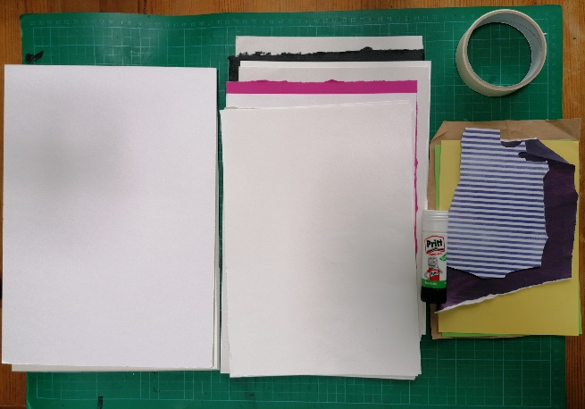
For the sketchbook
Mountcard offcuts x 2 (same size for covers) Masking tape
10 sheets of various textured/coloured papers Pritt stick
- Decide on how you want to arrange the papers (in what order) I suggest a stronger piece at regular intervals through the middle to ensure the stability of the book when stood upright on display
- Tape the papers together, side by side ensuring at least one edge is flush
- Fold taped papers in a zig zag (at taped edge)
- Glue each end to a piece of mountcard
- It’s recommended to allow the glue time to dry, don’t use the sketchbook straight away (a few hours should suffice)
For the sketchbook cover
Alison Moger’s session shows how to make a cover for your handmade sketchbook as well as other tips on filling your pages and recommends felt, fabrics, pins, embroidery thread…
OR you could drqw/paint on your cover as though they are extra pages in your book

For the drawing en plein air (outdoors) and in the studio
Pieces of scrap paper – for collage Pritt stick
Scissors/scalpel blade Charcoal
Putty rubber Cheap hairspray
Fillable water paint brushes Water soluble graphite stick
Watercolour paint (pans are more portable) Waterproof fineliner
Using the concertina sketchbook
Select a theme – I suggest your environment – indoors & out – local & further afield
Use one page at a time AND work over multiple pages varying the scale of your work
Use the book both portrait & landscape
Use panoramic views (over a number of pages) as well as close observation
Work quickly & loosely as well as produce detailed observational drawings
Use both sides
The drawing materials
Practice mark making with all of them before you draw anything. Do this straight onto the pages of your book, don’t worry about just filling it with beautiful drawing, fill it with beautiful marks too
Think formal elements:
Texture Line Colour Depth Perspective
Symmetry Asymmetry Shape Form Balance
Contour Tone (etc)
Work from BOTH primary & secondary sources
Primary source – actual objects on location
Secondary source – working from photos taken on location (this is useful when the weather changes and forces you to go back indoors)
Alter your photos with filters (greyscale, different colours etc) for further inspiration
Paint with charcoal - yes paint! Using plain water, or mixing watercolour with charcoal makes it less dusty to work with and gives some interesting effects
Draw with charcoal – additive & reductive.
Additive – build your drawing in terms of light & dark not line & shape
Reductive – cover an area in charcoal, then draw with the putty rubber, revealing lights from the dark
Water soluble graphite –
- apply a wet paint brush to the stick to lift some of the pigment to work with
- draw as you would with a normal graphite stick, then wash water over it afterwards
- dip the water soluble graphite into water & draw (keep dipping)
Watercolours & waterproof fineliner –
Paint some watercolour grounds before going out with your sketchbook
Use loose washes outdoors, plenty of water, work quickly
Try holding your brush in different ways to get various effects/different marks
Mix with charcoal (as above) & the water soluble graphite
Draw with the waterproof fineliner first, then paint loosely within the shapes drawn
Paint with watercolour first then add hard edges to elements with the waterproof fineliners
For Collage
Add elements of collage to some of your pages before going outdoors to work as this will inspire you to approach the page differently
Use hand painted papers to add texture to your collages
Work in layers taking each component one at a time
Use mixed media – collage, draw/paint over this
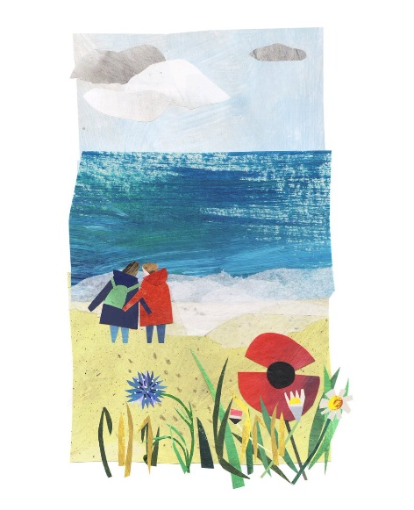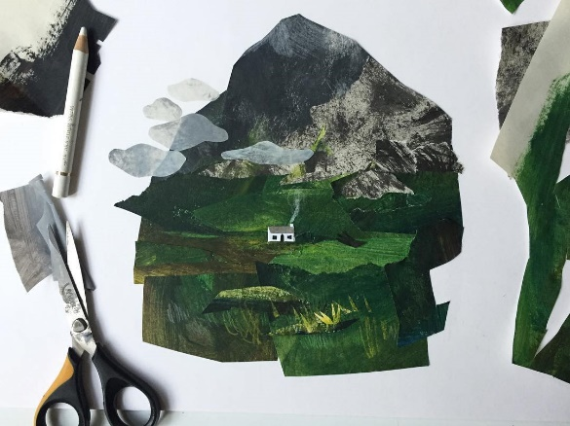
Artist Clover Robin Instagram @clover_robin www.cloverrobin.com

Combine all or any of the above
The more you experiment, the more you will learn about the strengths and limitations of your materials.
Have fun!

Claire Hiett
August 2020

