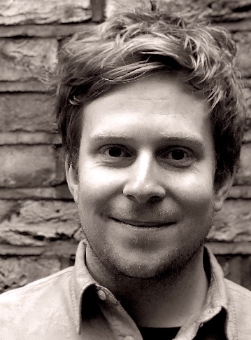
Gareth Moorcraft – course tutor

Gareth Moorcraft (b.1990) is a British composer based in London and South Wales.

His music has been performed and broadcast internationally by leading ensembles including the Philharmonia Orchestra, the BBC National Orchestra of Wales, the London Philharmonic Orchestra, and soloists and chamber ensembles including Tabea Debus, Tom Poster, Endymion, Chroma, and the Solem Quartet.
Gareth was awarded an Ivor Novello Award in the solo/duo category of The Ivors Composer Awards 2020. He is also the recipient of the prestigious RPS Composition Prize (2016), the Ty Cerdd Composition Prize (2012), and the inaugural BASCA British Composer Awards Student Prize (2012). Recordings of Gareth’s work have been released by NMC Recordings and Delphian Records.

Gareth’s recent music often engages with ‘creative transcription’, recycling and distorting historical materials and musical tropes and presenting them in unusual new contexts. Alongside his diverse collection of concert works, projects have also included collaborations with dance companies (The National Dance Company of Wales, and The New Dance Collective, Hamburg), site-specific installations (Swansea International Festival; Artes Mundi 6), and live film projects with Chroma Ensemble and Sinfonia Cymru. Gareth has also undertaken residencies with numerous festivals and ensembles, notably a site-specific choral work for the Dartington Festival, a new spatial work for the Britten Studio at Snape Maltings (created as composer-in-residence for the Britten-Pears Advanced Brass Course), and a musical response to artworks in the Centre Dürrenmatt, Neuchâtel, part of a European tour for Gareth’s song cycle I am your reflection.

Gareth is a composition professor and researcher at the Royal Academy of Music, London. In 2019, he established the RAM’s Young Composer Club, which provides workshop opportunities for young composers studying in London state schools. He is passionate about music education and runs composition workshops with numerous music organisations and festivals in the UK.

