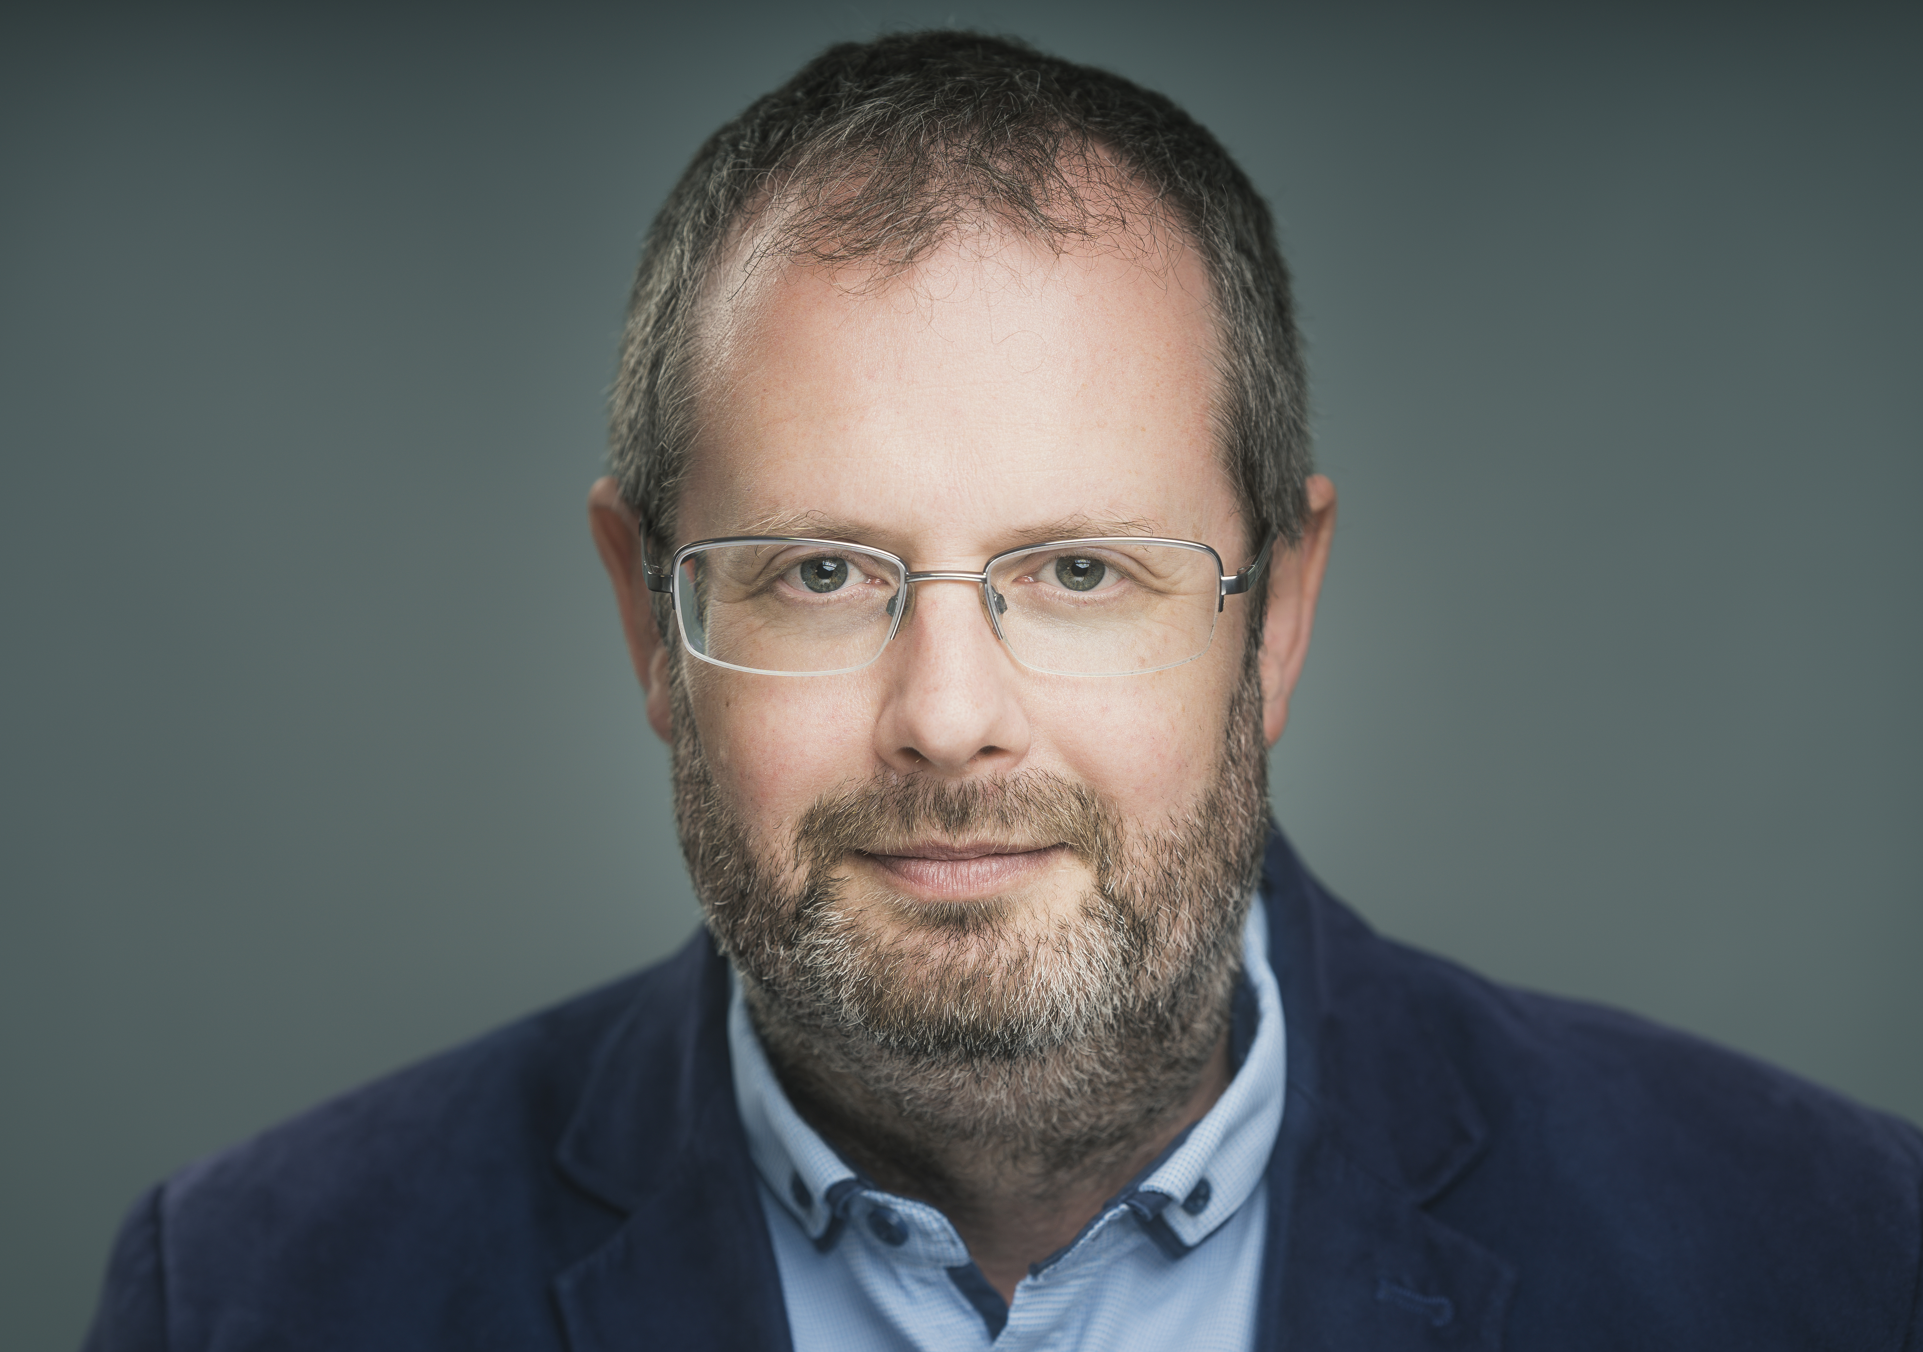

Biography – Robert Fokkens

Robert Fokkens’ music is performed and broadcast internationally, published by Composers Edition and Tetractys Publishing, and recorded on ECM, Nimbus, Métier, Herald, Naxos and other labels. He is a South African-born composer working in the UK, and Reader in Composition at Cardiff University.

Robert’s music uses techniques and materials learned from many musical worlds, creating music of twisted cycles and microtonal inflections described as ‘hilarious’, ‘sad [and] strange…express[ing] more than anything else’ (Times). Recently, his opera Bhekizizwe was premiered in Wales (2022), his violin/cello duo Pier Music was premiered and toured in the UK by David Adams and Alice Neary, and Mzantsi Nights was performed and broadcast in Germany and South Africa by Ensemble Modern (2023). Premiere recordings released in 2025 include string trios Dawn Chants on the Umfolozi and Limping Song recorded by Karolos (First Hand Records), and the Signum Quartet’s recording of glimpses of a half-forgotten future (ECM).

www.robertfokkens.co.uk

