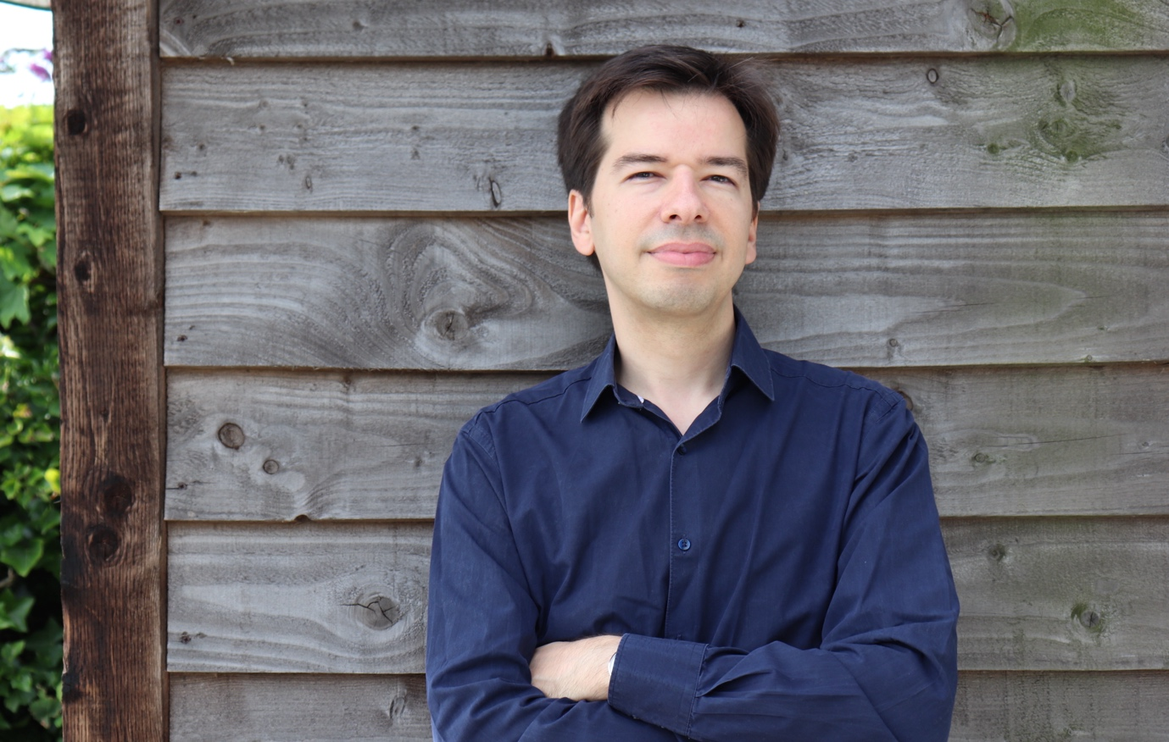

Pedro Faria Gomes is a Portuguese composer based in Wales whose music has been performed, recorded and broadcast internationally. His works have been released on labels including Naxos and Prima Facie, and have received awards in both the UK and Portugal, including the PRS Sir Arthur Bliss Memorial Award and SPA's Prémio Autores.

Pedro’s music has been commissioned by organisations including the London Symphony Orchestra, Teatro Nacional de São Carlos, Companhia Nacional de Bailado and Leiria UNESCO Creative City of Music. His work ranges from chamber, orchestral and vocal music to projects created for young performers and audiences.

Alongside his composing career, Pedro is Senior Lecturer in Composition at Cardiff University, where he teaches composition and supervises undergraduate, master’s and doctoral students. He enjoys working with young composers and helping them develop their musical ideas, creativity and confidence.

www.pedrofariagomes.com

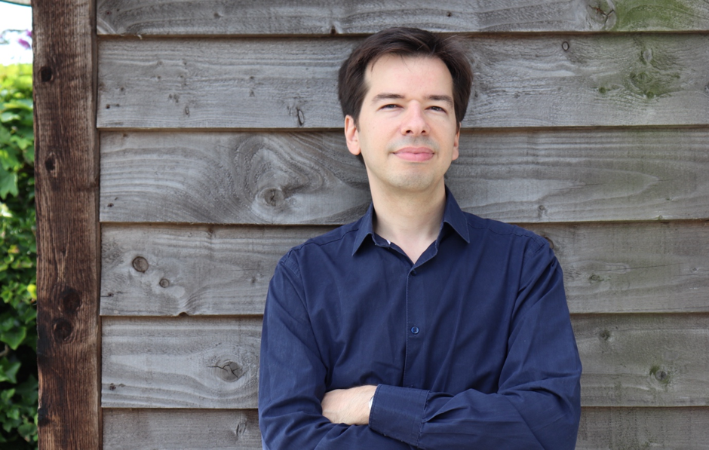

Mae Pedro Faria Gomes yn gyfansoddwr o Bortiwgal sy’n byw yng Nghymru, y mae ei gerddoriaeth wedi'i pherfformio, ei recordio a'i darlledu'n rhyngwladol. Mae ei weithiau wedi cael eu rhyddhau ar labeli gan gynnwys Naxos a Prima Facie, ac wedi derbyn gwobrau yn y DU a Phortiwgal, gan gynnwys Gwobr Goffa PRS Syr Arthur Bliss a Prémio Autores SPA.

Mae cerddoriaeth Pedro wedi'i chomisiynu gan sefydliadau gan gynnwys Cerddorfa Symffoni Llundain, Teatro Nacional de São Carlos, Companhia Nacional de Bailado a Dinas Cerddoriaeth Greadigol UNESCO Leiria. Mae ei waith yn amrywio o gerddoriaeth siambr, gerddorfaol a lleisiol i brosiectau a grëwyd ar gyfer perfformwyr a chynulleidfaoedd ifanc.

Ochr yn ochr â'i yrfa gyfansoddi, mae Pedro yn Uwch Ddarlithydd mewn Cyfansoddi ym Mhrifysgol Caerdydd, lle mae'n dysgu cyfansoddi ac yn goruchwylio myfyrwyr israddedig, meistr a doethuriaeth. Mae'n mwynhau gweithio gyda chyfansoddwyr ifanc a'u helpu i ddatblygu eu syniadau cerddorol, eu creadigrwydd a'u hyder.

www.pedrofariagomes.com

